**PART II: Network**

1. **Explorer: Explore latest blockchain data.**

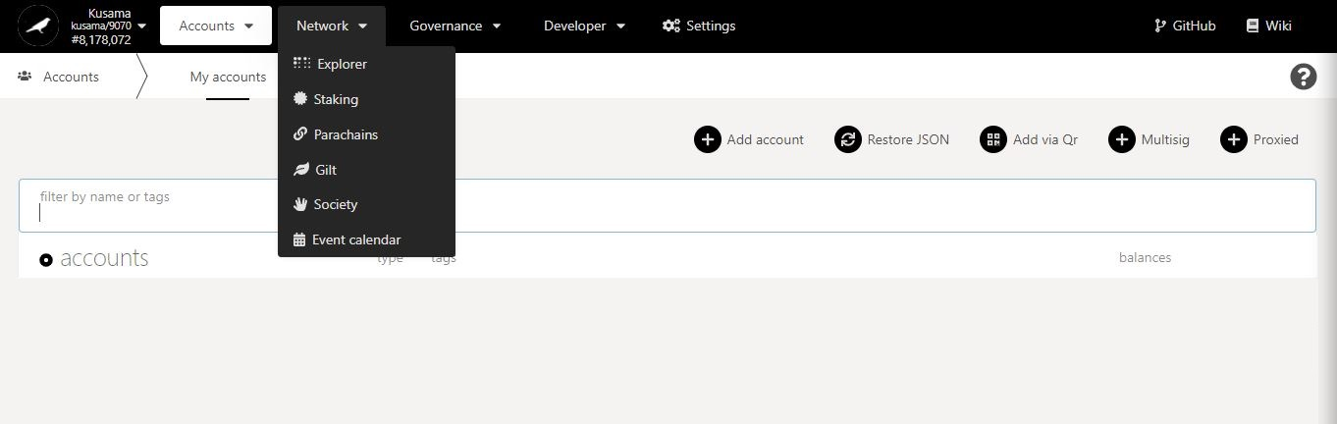

* 1. **View blockchain information.**

**Search** block hashes or block numbers.

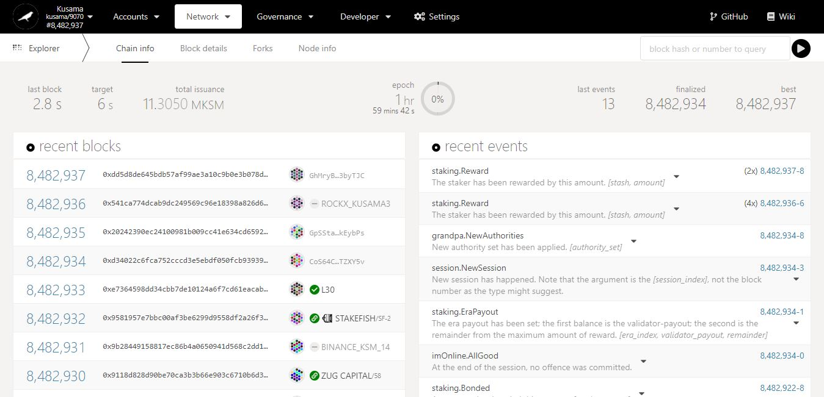

Recent **block hashes**.

Recent **block numbers**.

Key information on blockchain: **time elapsed since last block, targeted block time, total KSM supply, epoch countdown, blocks’ statistics.**

Recent **block validators**.

Overview of transactions/operations **included in recent blocks**.

* 1. **View block details.**

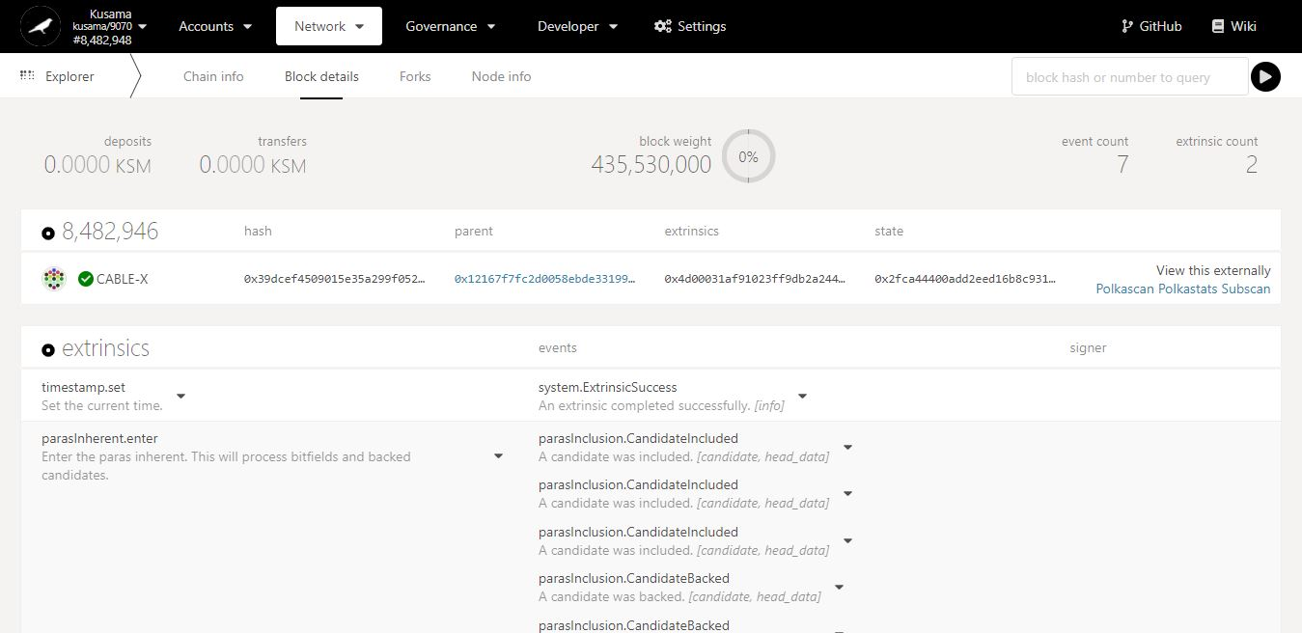

Key information on current block: **amounts transferred, block weight, and number of transactions.**

Extrinsics & Events in detail:

An event isa piece of data **from within the blockchain** (ex: issue a reward payout from my validator).

An extrinsic isa piece of data **from the outside world** (ex: claim a reward payout for my stash).

Overview of transactions/operations **included in this block**. Note: Click on the dropdown arrow to view each individual transaction/operation in greater detail.

* 1. **Monitor blockchain forks.**

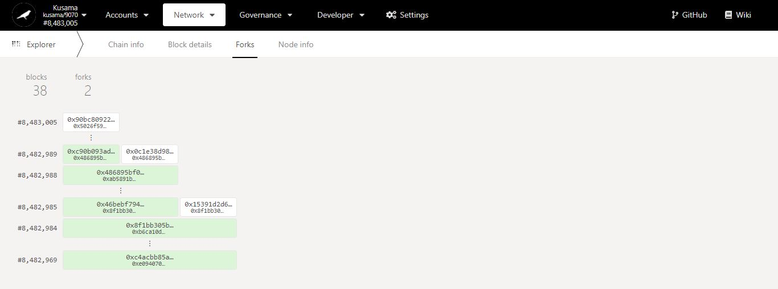

Key information on forks: **number of blocks captured, and number of forks encountered since monitoring started.**

Last **propagated** block number and block hash **(white colour)** captured by this node since monitoring started.

Last **finalised** block number and block hash **(green colour)** captured by this node since monitoring started.

**2nd fork.**

**1st fork.**

* 1. **Monitor blockchain nodes information.**

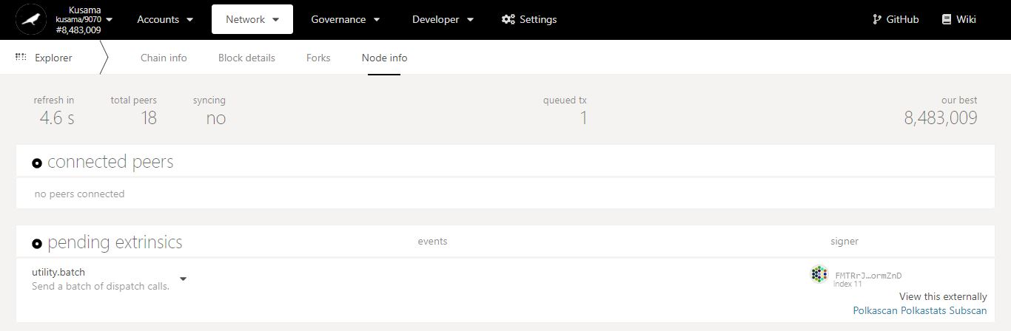

Key information on current node: **countdown to refresh, peer nodes, sync status.**

Latest block number **captured.**

**Sender(s)** of the transaction(s) in queue**.**

**Nature** of the transaction(s) in queue.

Number of **transaction(s)** in queue**.**

Number of node(s) **connected to this node.**

1. **Staking: Explore staking-related operations.**



**Basic information on technical words** used in the STAKING section.

* 1. **View general staking information.**

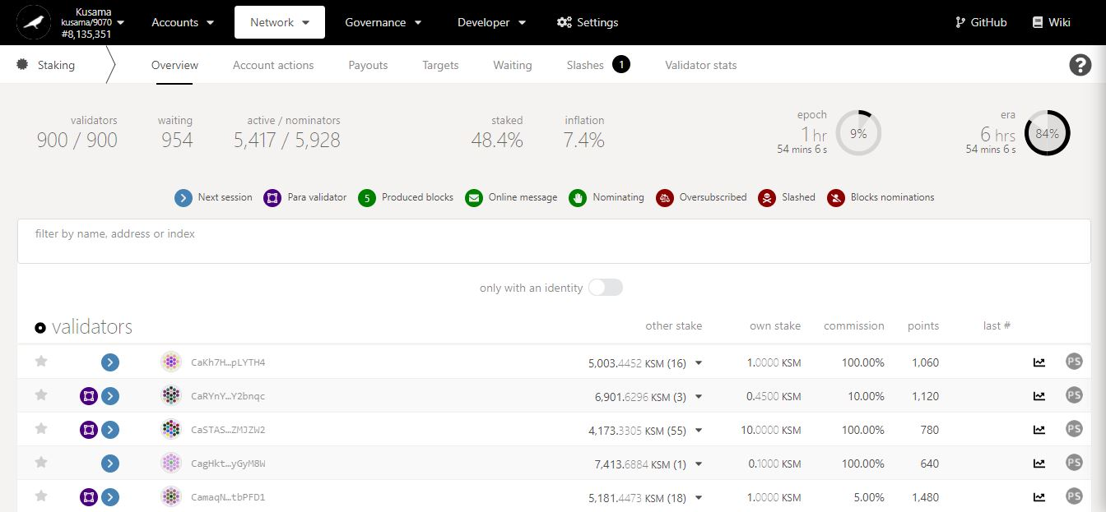

Key information on **validators, nominators and staking statistics.**

Countdown to the **inclusion of new nominators into the list of rewardees**.

Summary of **validators’ balances, commissions, and performance.**

Addresses of **currently elected validators**.

**NEVER SEND YOUR KSM TO A VALIDATOR’S ADDRESS!**

* 1. **Manage account nominations:**
* **Set nominators.**

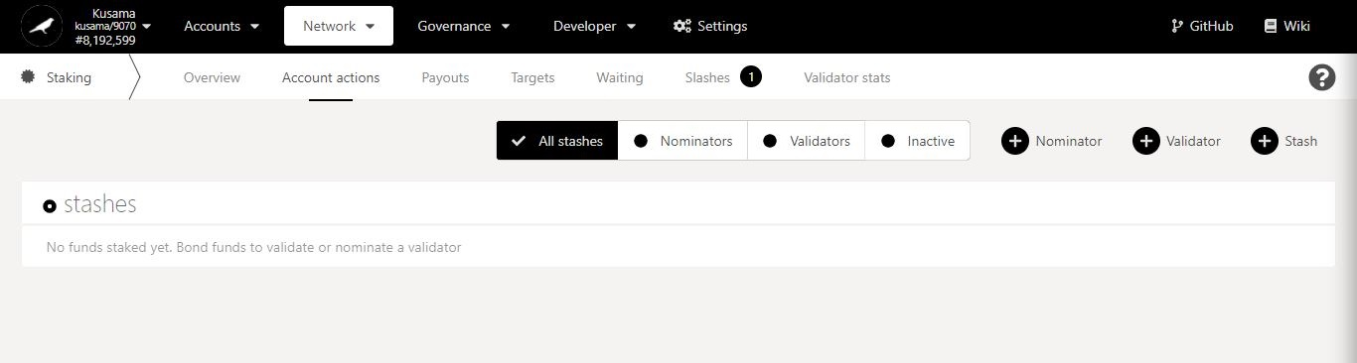

1. Click **Nominator**.

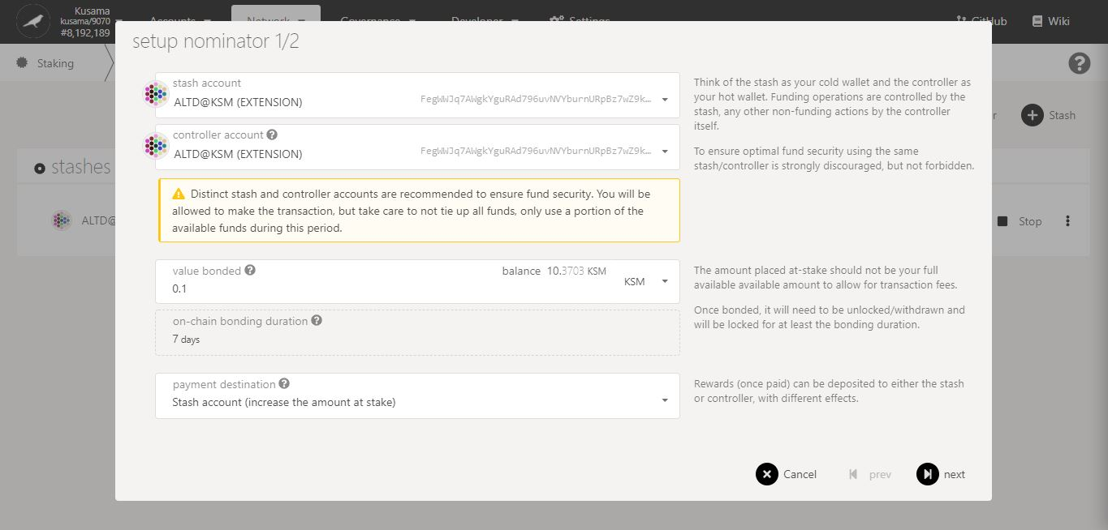

2. Follow **on-screen instructions** carefully.

3. Double-check **warning messages.**

**[Troubleshooting 1/4]**

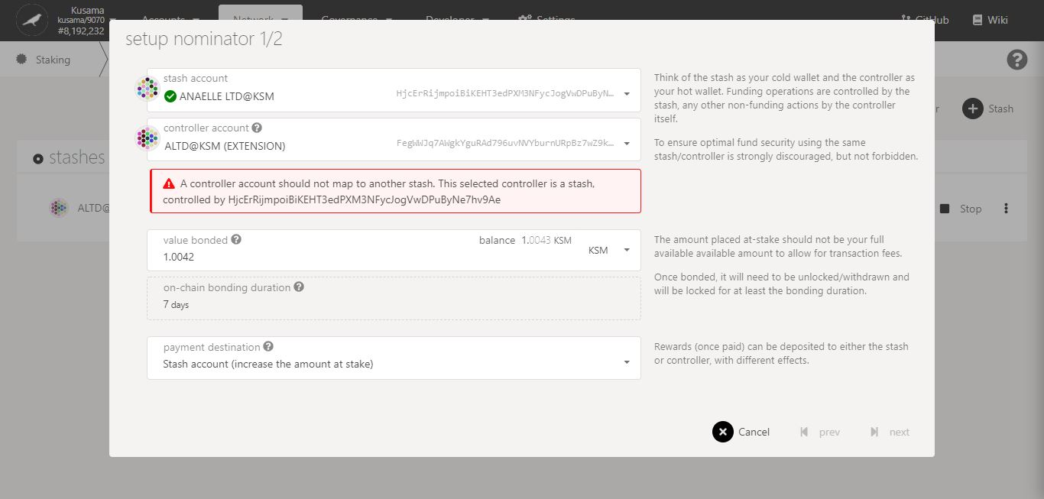

Issue:

You are trying to **use an existing stash as a controller for your new stash**!

Possible solution(s):

- Make the new stash and its controller identical.

- Create a new Polkadot-JS account and set it as the controller to the new stash.

Double-check **error messages.**

**[Troubleshooting 2/4]**

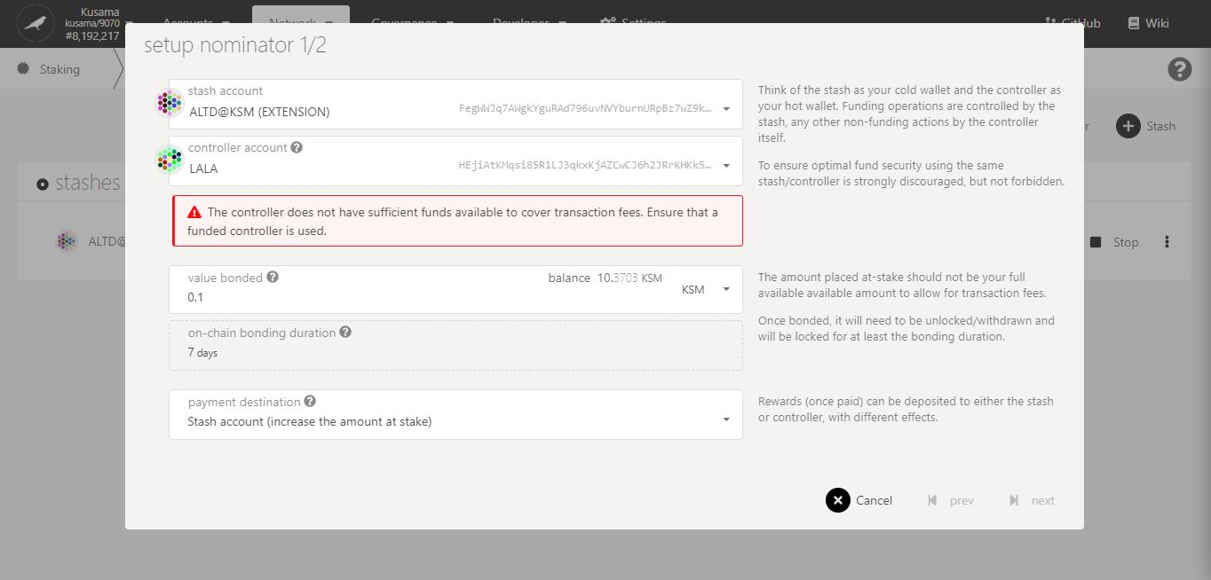

Issue:

Your chosen controller **does not have enough KSM to pay for the transaction fees!**

Possible solution(s):

- Add more funds to your chosen controller’s balance.

- Use a different controller that has a sufficient KSM balance.

Double-check **error messages.**

**[Troubleshooting 3/4]**

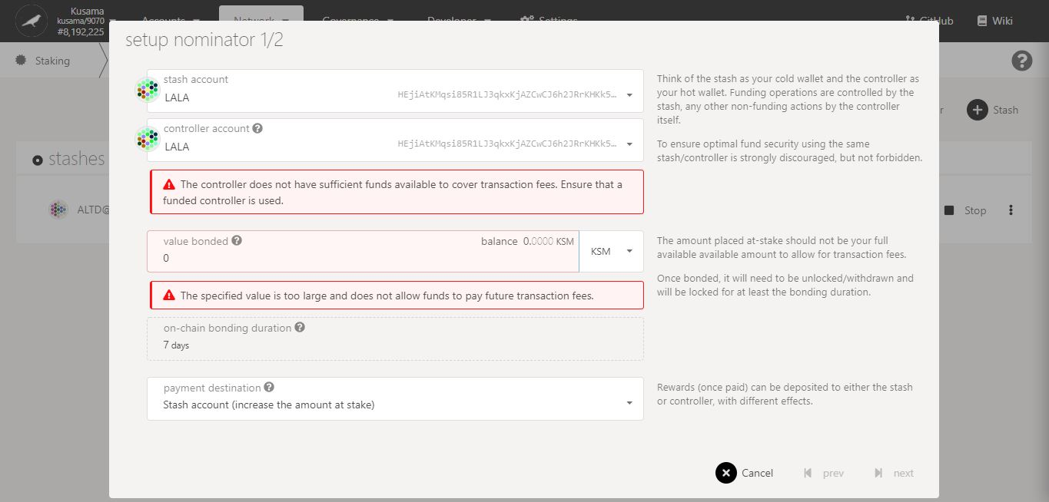

Issue:

Your stash and controller **do not have enough KSM to bond for the nominations and to pay for the transaction fees**!

Possible solution(s):

- Add more funds to your stash balance and controller balances. Note: A minimum of 0.1KSM is needed to nominate.

- Bond more funds into a pre-existing stash that has a some spare KSM.

Double-check **error messages.**

**[Troubleshooting 4/4]**

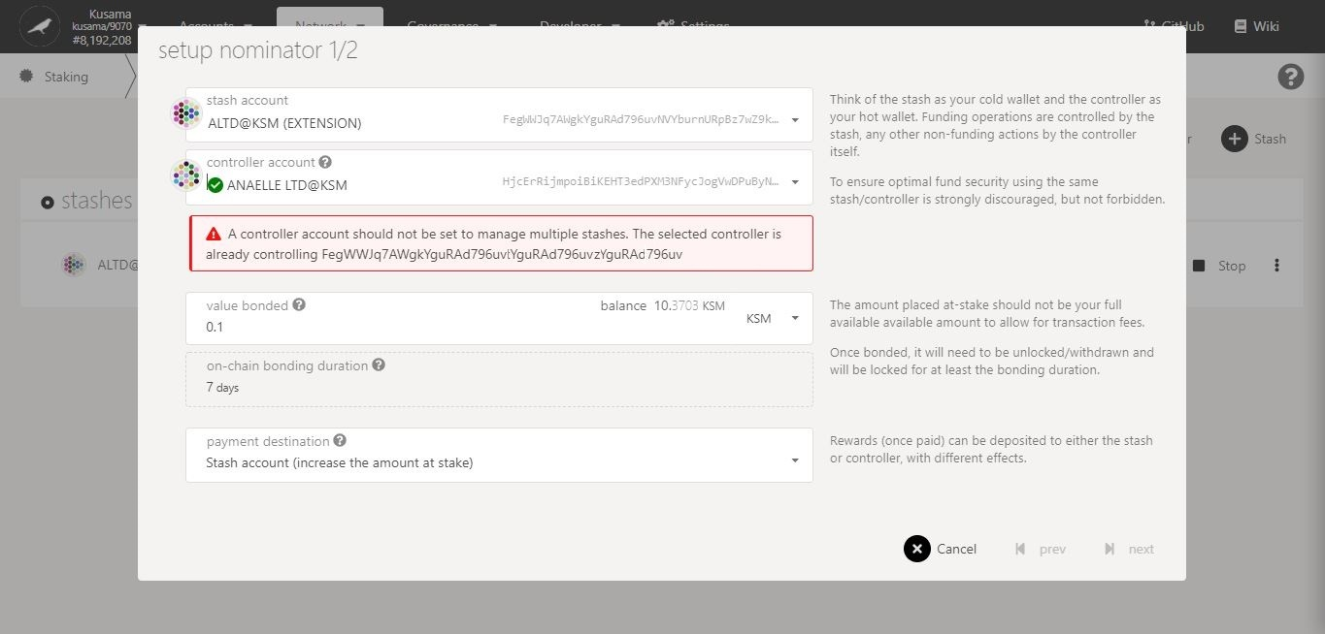

Issue:

You are trying to **use one controller for many stashes**!

Possible solution(s):

- Make the new stash and its controller identical.

- Create a new Polkadot-JS account and set it as the controller to the new stash.

Double-check **error messages.**

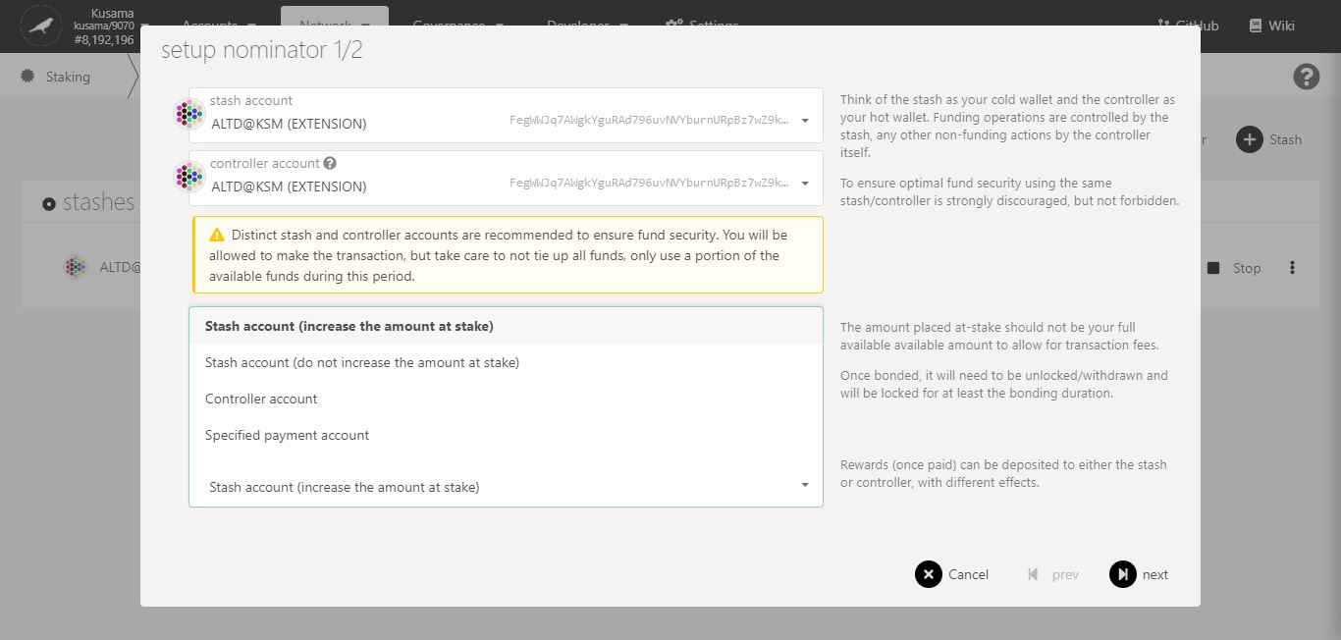

4. Select **one** option for **receiving reward payouts**.

5. Click on **Next** to continue the procedure.

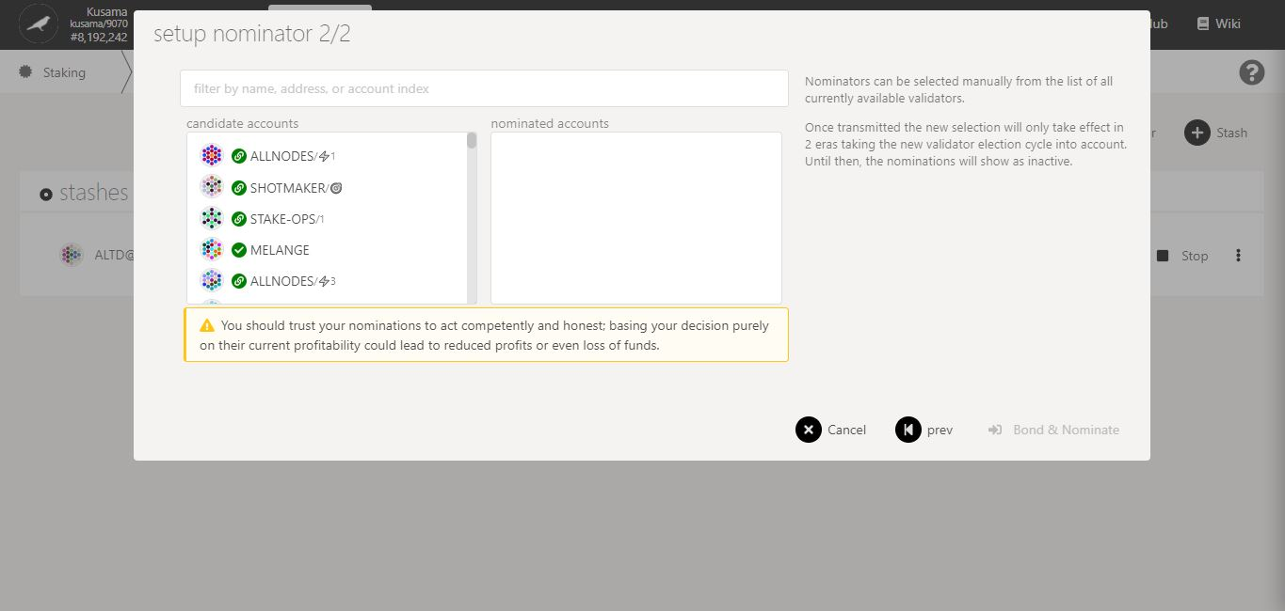

6. Follow the **new instructions** carefully.

7. Double-check **warning messages.**

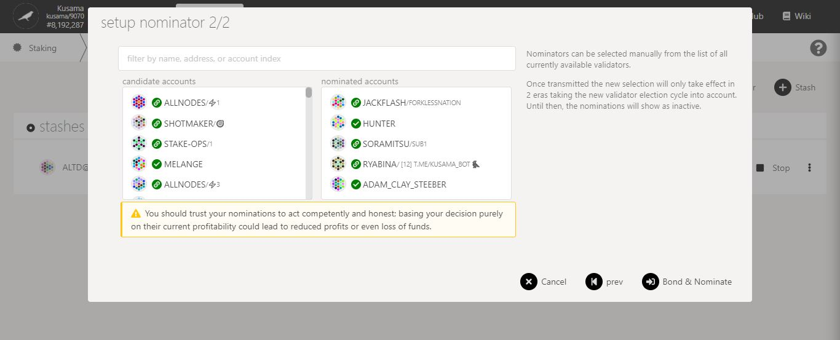

8. Click on **10-16** **validators’ names or addresses** to add them to **your selection**.

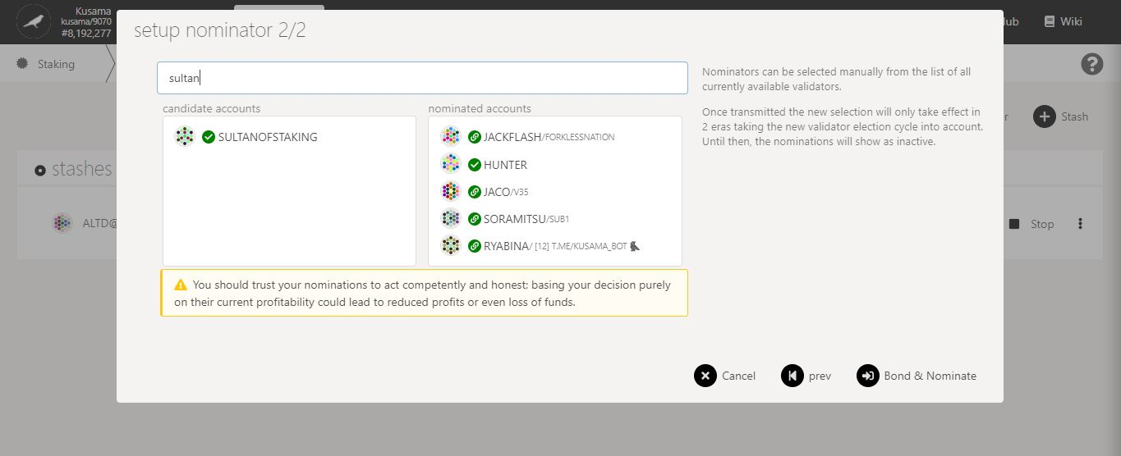

9. You can **search for your favourite validator** to speed up this process.

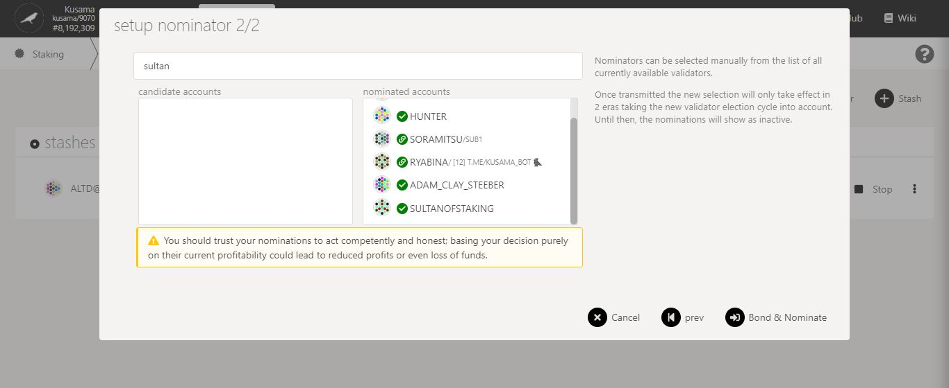

11. Click on **Bond & nominate** to continue the procedure.

10. Double-check your **selection of validators.**

**Nature** of the transaction.

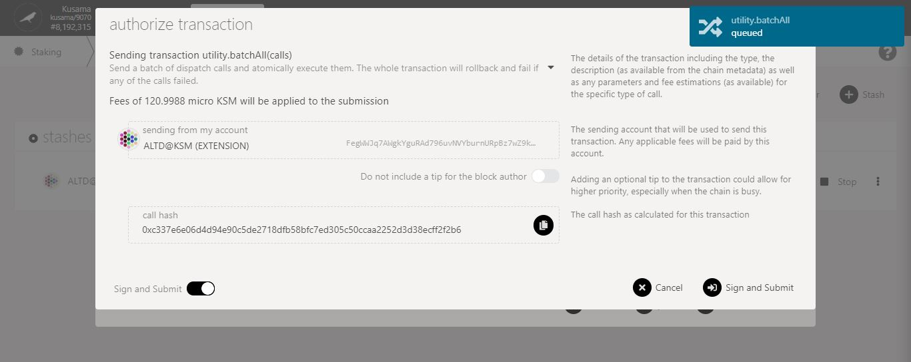

**More validators**

= more nominations

= **higher transaction fees**.

12. Follow the **final instructions** carefully.

13. Click on **Sign & submit** to continue the procedure.

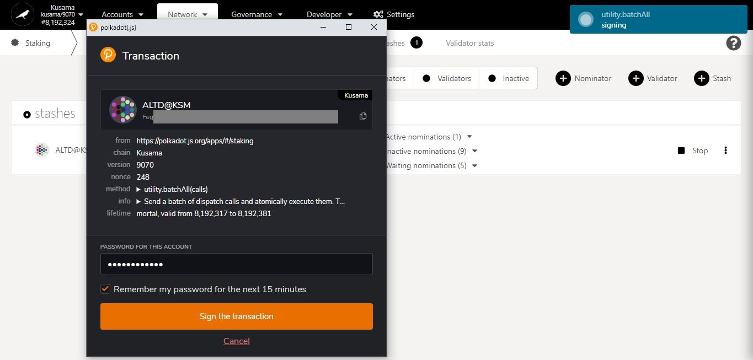

15. Click on **Sign the transaction** to complete the procedure.

14. Enter **your account’s password** and tick the box to **remember your password, if necessary**.

**Summary** of the transaction sent via the Polkadot-JS extension.

**Progress** of the transaction.

* **Add stashes.**

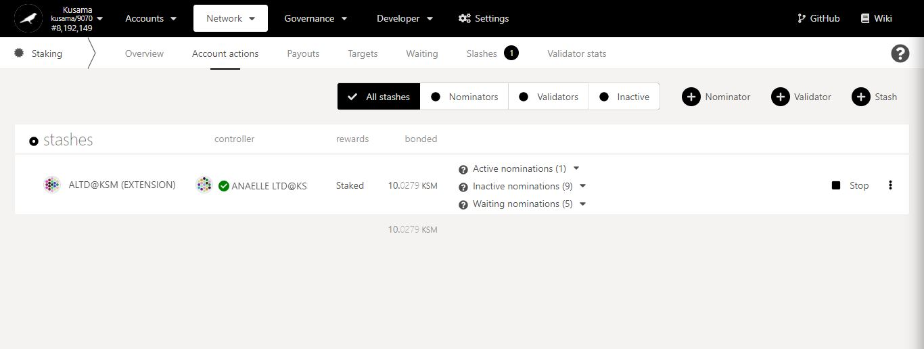

1. Click **Stash**.

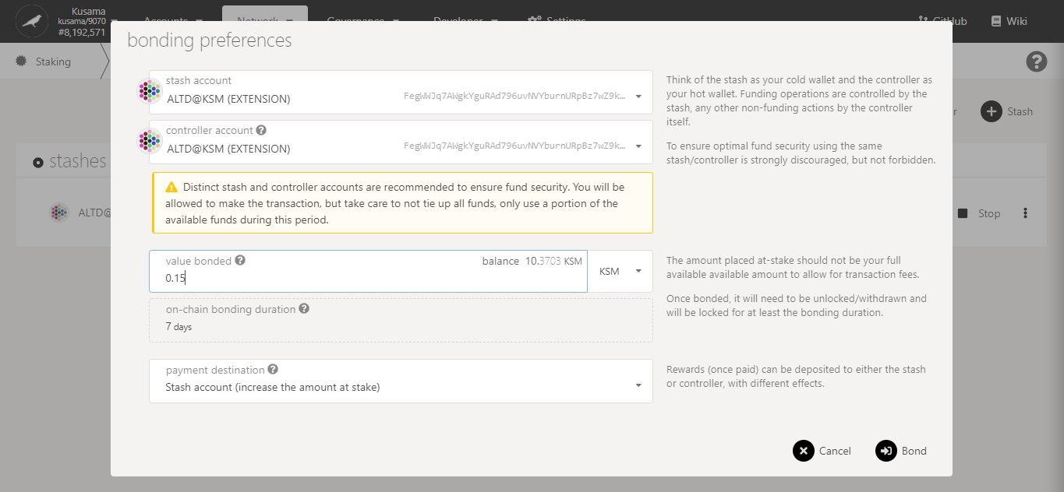

4. Click on **Bond** to continue the procedure.

3. Double-check **warning messages.**

2. Follow **on-screen instructions** carefully.

**Nature** of the transaction.

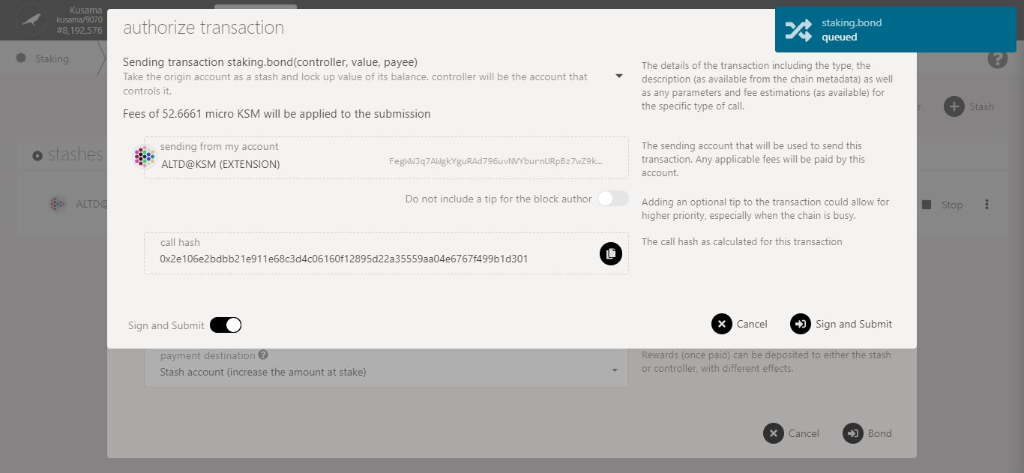

5. Check the **transaction fees**.

6. Click on **Sign & submit** to continue the procedure.

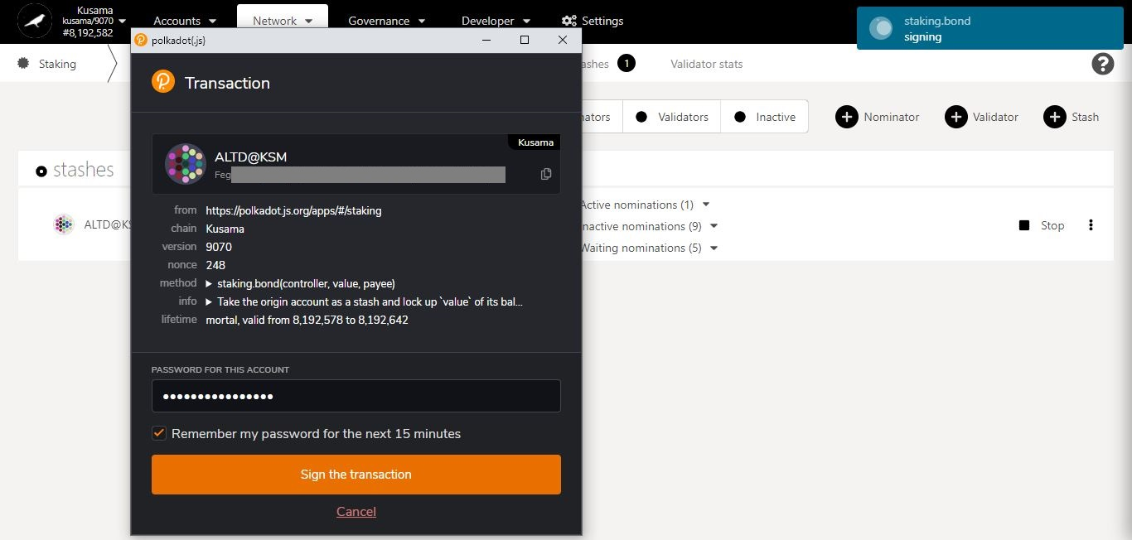

**Summary** of the transaction sent via the Polkadot-JS extension.

8. Click on **Sign the transaction** to complete the procedure.

7. Enter **your account’s password** and tick the box to **remember your password, if necessary**.

**Progress** of the transaction.

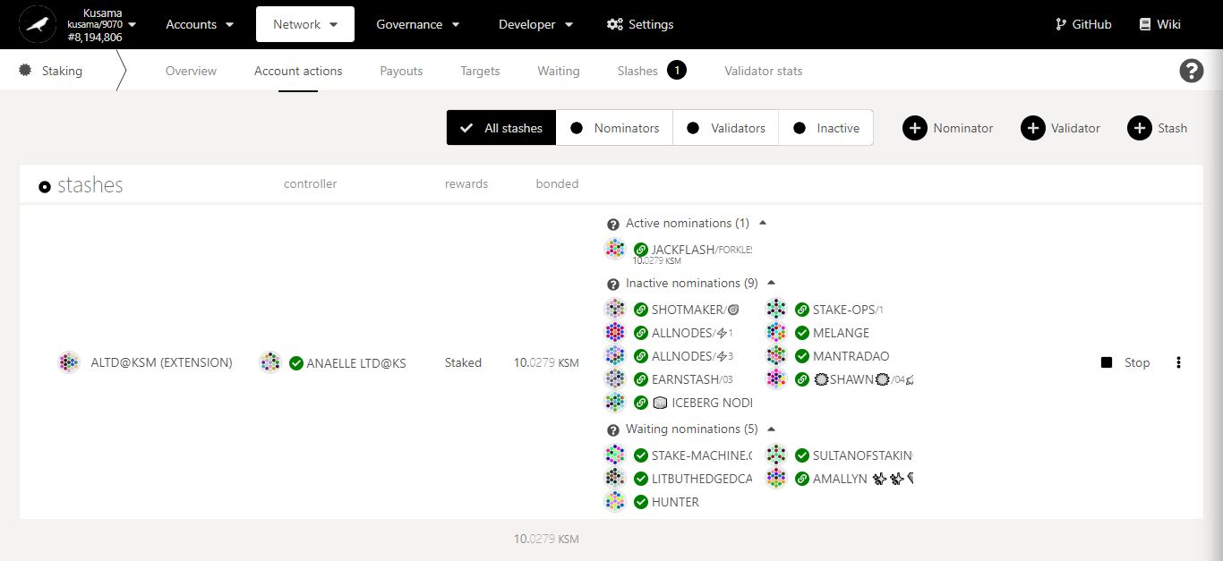

Staking summary:

**Staked:** Total balance of KSM bonded/locked into nominations (includes reward payouts made into the stash).

**Active nominations:** Nominated validator that is in the active set and making reward payments for the current era.

**Inactive nominations:** Nominated validators that are in the active set but not making reward payments for the current era.

**Waiting nominations:** Nominations waiting to be included in the active set or in the list of rewardees.

Stop all **nomination activities associated with this stash.**

Name of **the controller**.

It is used to **set nominees for bonded KSM on behalf of a stash**.

Name of **the stash**.

It is used to **bond KSM for nominations and set a controller.**

It can be used **to compound reward payouts.**

**View** all the stashes associated to your existing accounts.

* **Bond more funds.**



1. Click on the 3 vertical dots to view **Staking settings**.

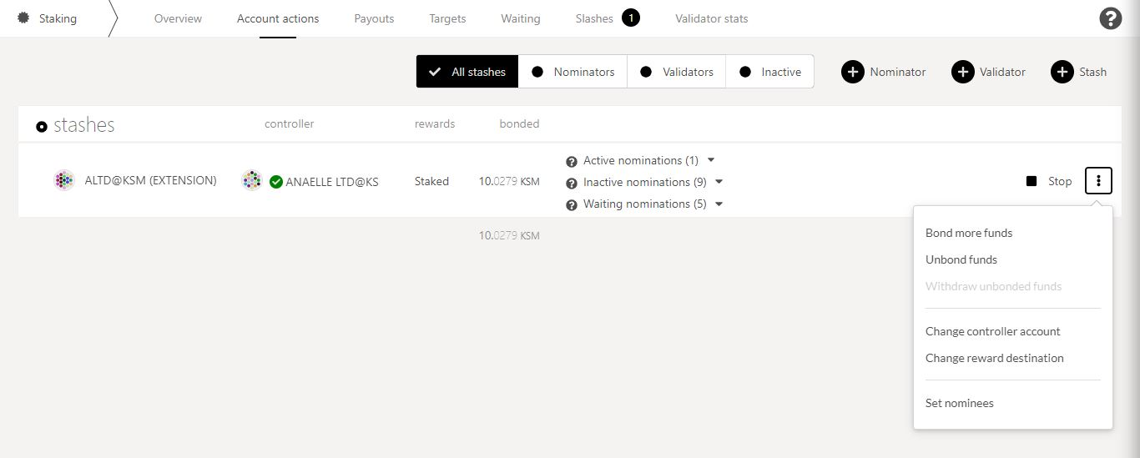

2. Click on **Bond more funds** to increase the amount of KSM you are staking.

3. Follow **on-screen instructions** carefully.

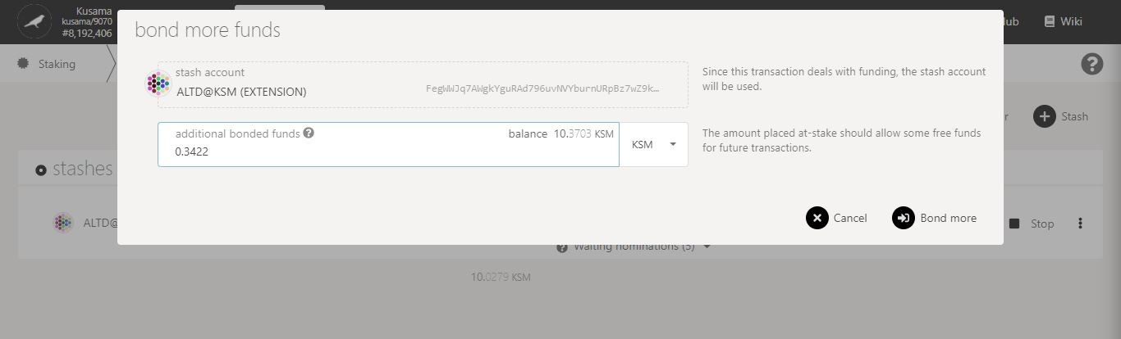

4. Click on **Bond more** to continue the procedure.

**Nature** of the transaction.

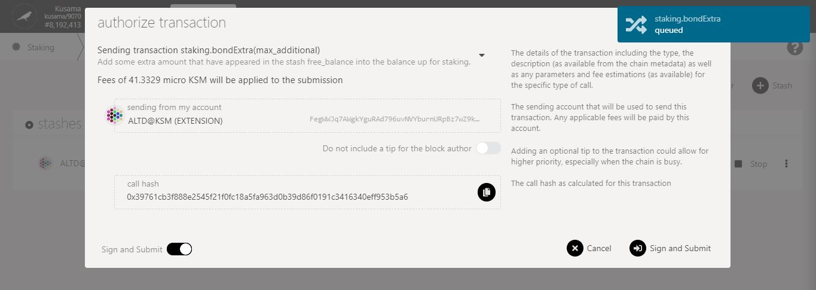

5. Check the **transaction fees**.

6. Click on **Sign & submit** to continue the procedure.

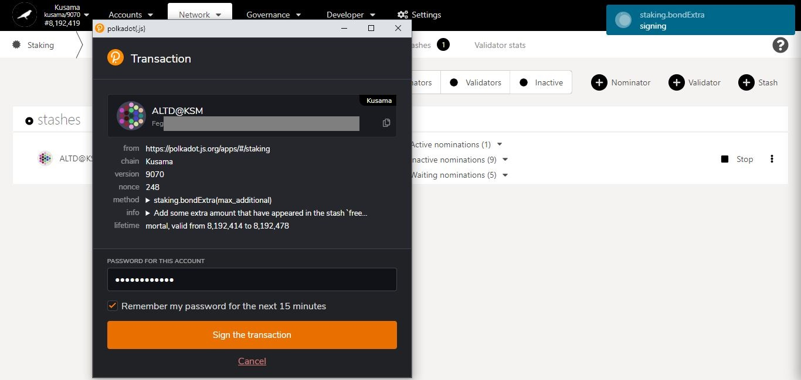

**Summary** of the transaction sent via the Polkadot-JS extension.

8. Click on **Sign the transaction** to complete the procedure.

7. Enter **your account’s password** and tick the box to **remember your password, if necessary**.

**Progress** of the transaction.

* **Unbond funds.**



1. Click on the 3 vertical dots to view **Staking settings**.



2. Click on **Unbond funds** to decrease the amount of KSM you are staking.

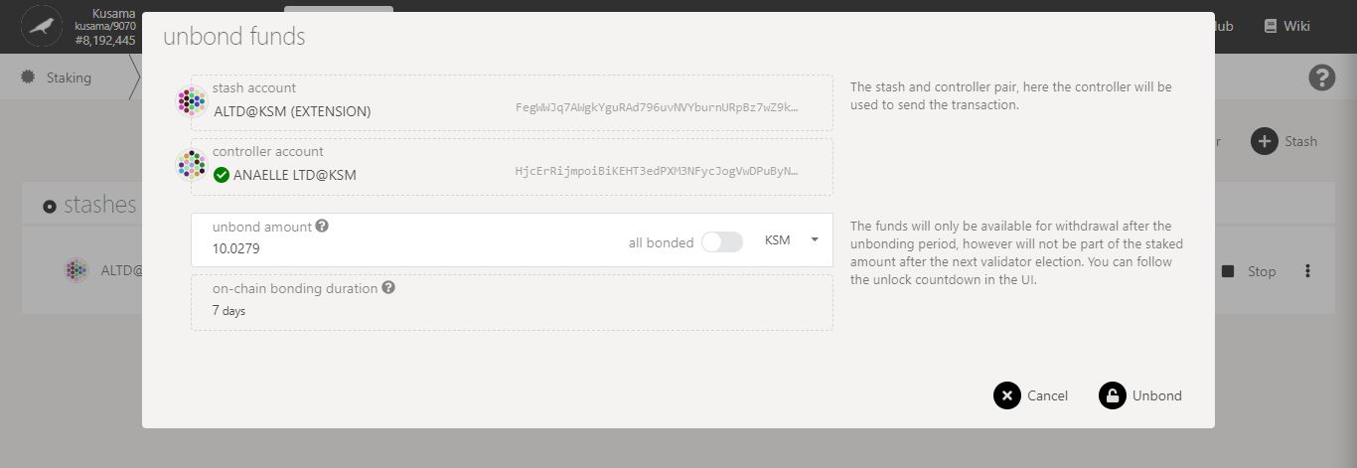

4. Click on **Unbond** to continue the procedure.

3. Follow **on-screen instructions** carefully.

**Nature** of the transaction.

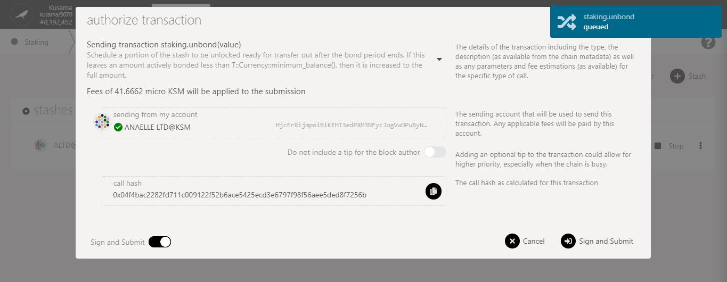

5. Check the **transaction fees**.

6. Click on **Sign & submit** to continue the procedure.

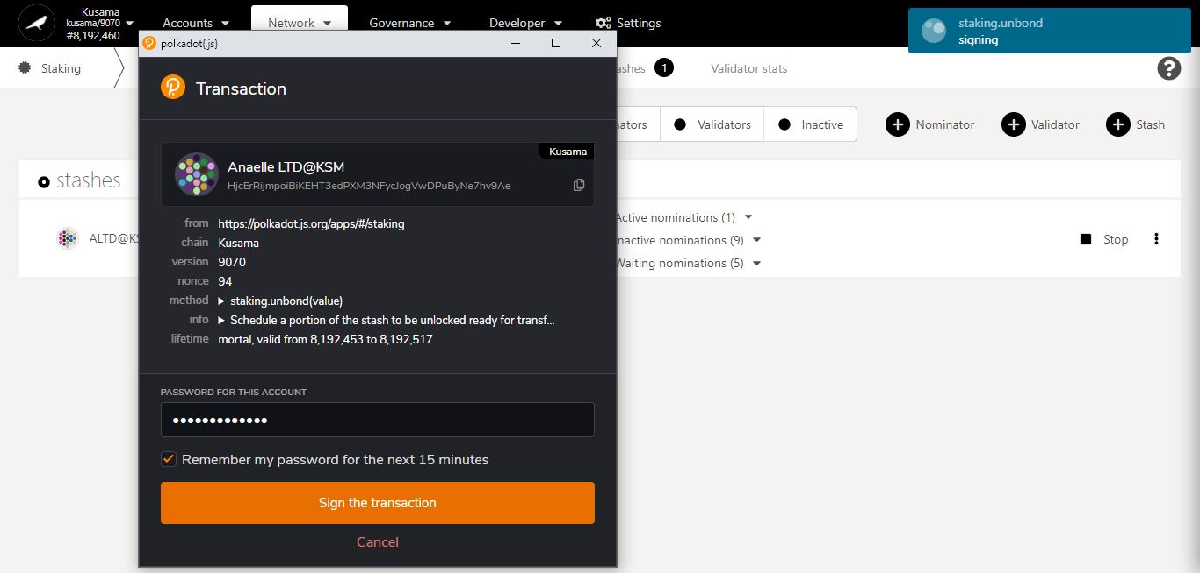

8. Click on **Sign the transaction** to complete the first part of the unbonding procedure.

**Summary** of the transaction sent via the Polkadot-JS extension.

7. Enter **your account’s password** and tick the box to **remember your password, if necessary**.

**Progress** of the transaction.

9. **Your funds have now entered an unbonding period!** **You will need to wait for 7 days before you can complete the procedure.**

10. **After 7 days, your unbonded funds are now ready to be withdrawn!**

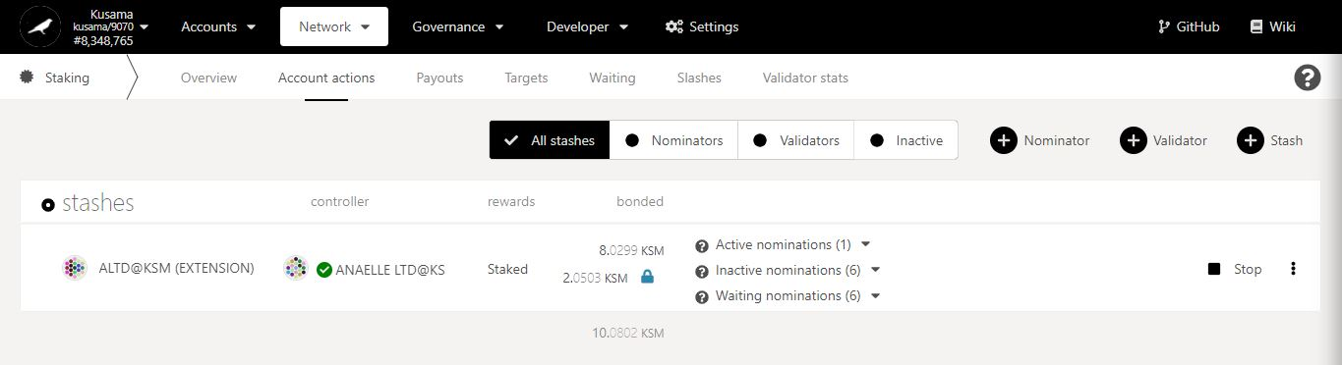

11. Click on the **padlock icon** to start the second part of the unbonding procedure.

**Nature** of the transaction.

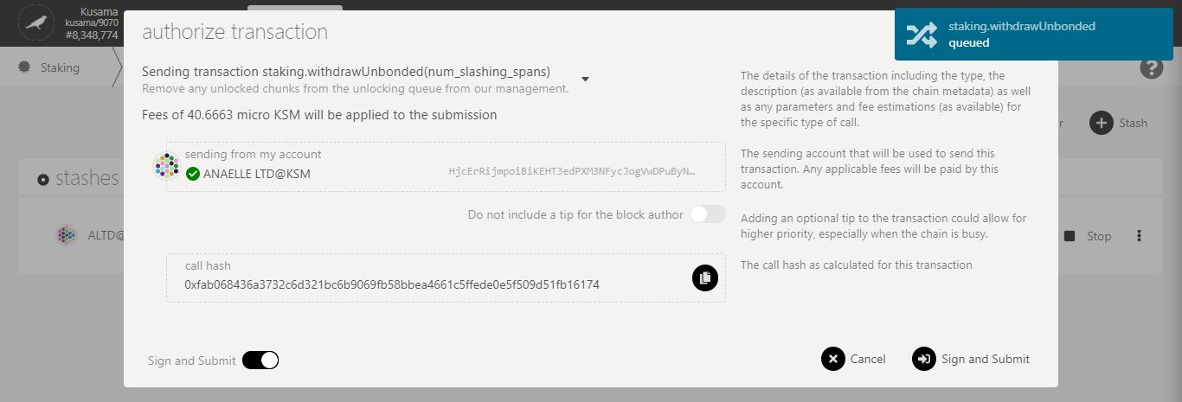

13. Click on **Sign & submit** to continue the procedure.

12. Check the **transaction fees**.

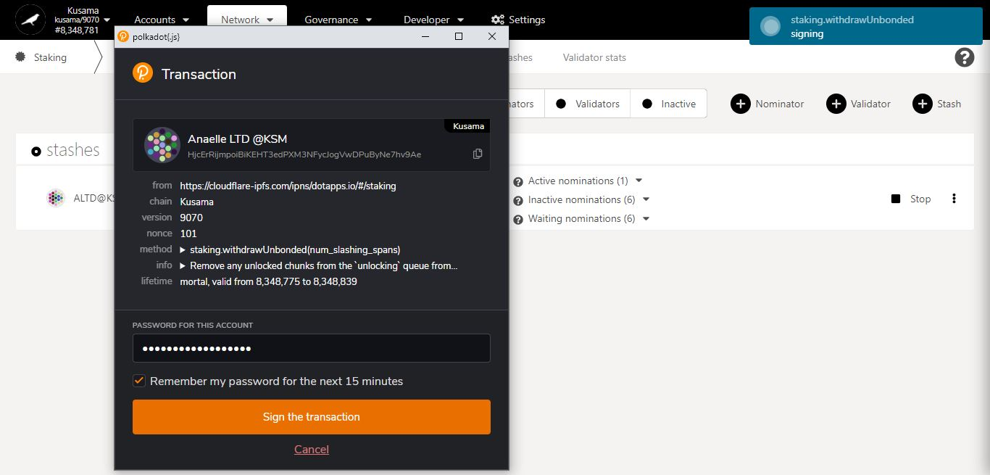

15. Click on **Sign the transaction** to complete the unbonding procedure.

**Summary** of the transaction sent via the Polkadot-JS extension.

14. Enter **your account’s password** and tick the box to **remember your password, if necessary**.

**Progress** of the transaction.

* **Change controller account.**



1. Click on the 3 vertical dots to view **Staking settings**.



2. Click on **Change controller account** to set a new controller for this stash.

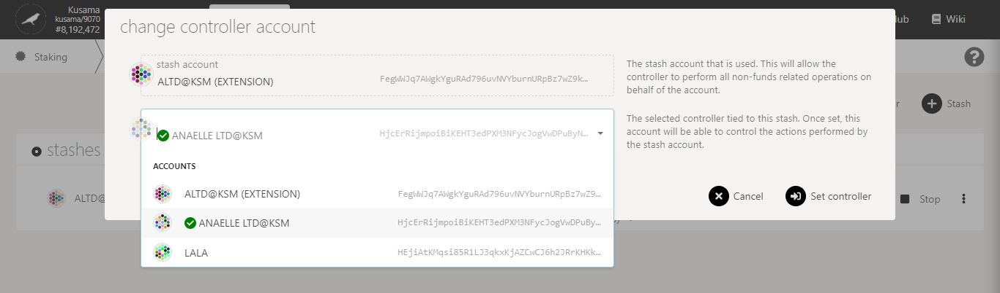

3. Follow **on-screen instructions** carefully.

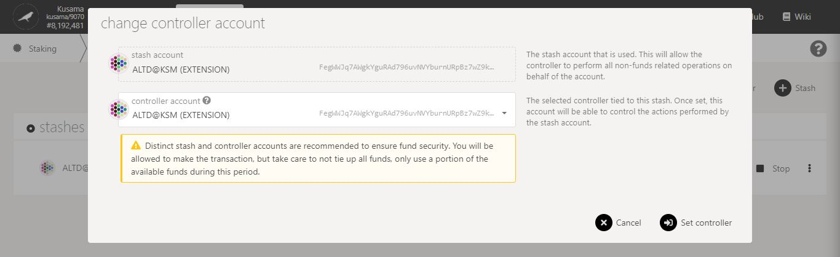

4. Double-check **warning messages.**

5. Click on **Set controller** to continue the procedure.

**Nature** of the transaction.

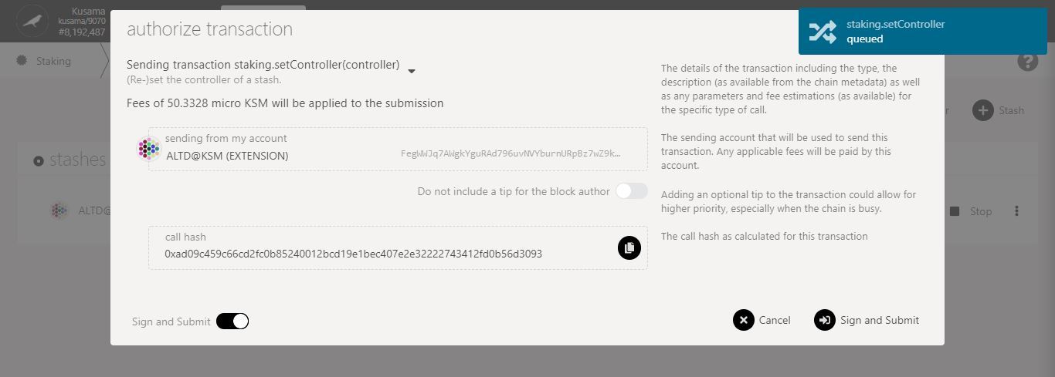

6. Check the **transaction fees**.

7. Click on **Sign & submit** to continue the procedure.

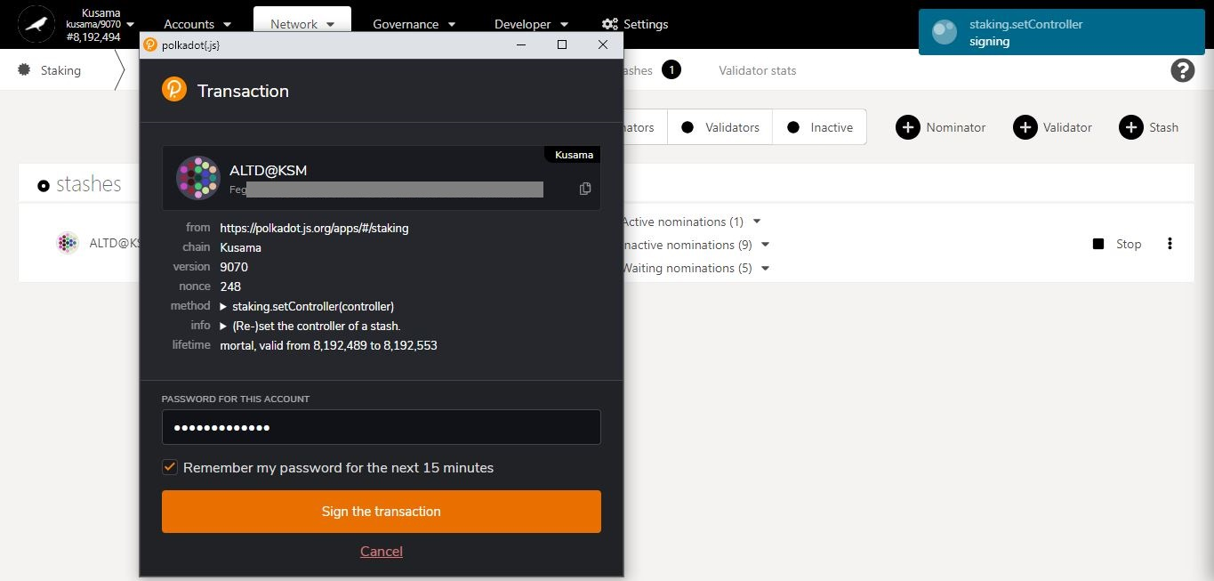

**Summary** of the transaction sent via the Polkadot-JS extension.

9. Click on **Sign the transaction** to complete the procedure.

8. Enter **your account’s password** and tick the box to **remember your password, if necessary**.

**Progress** of the transaction.

* **Change reward destination.**



1. Click on the 3 vertical dots to view **Staking settings**.



2. Click on **Change reward destination** to reset how/where your reward payouts are made.

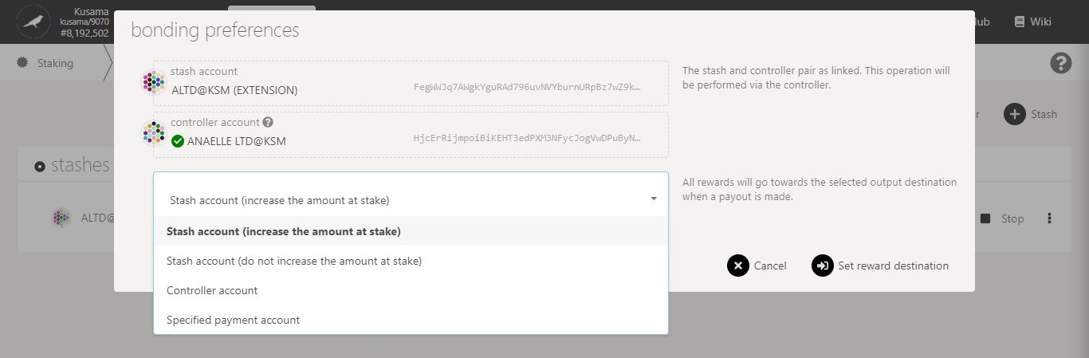

3. Follow **on-screen instructions** carefully.

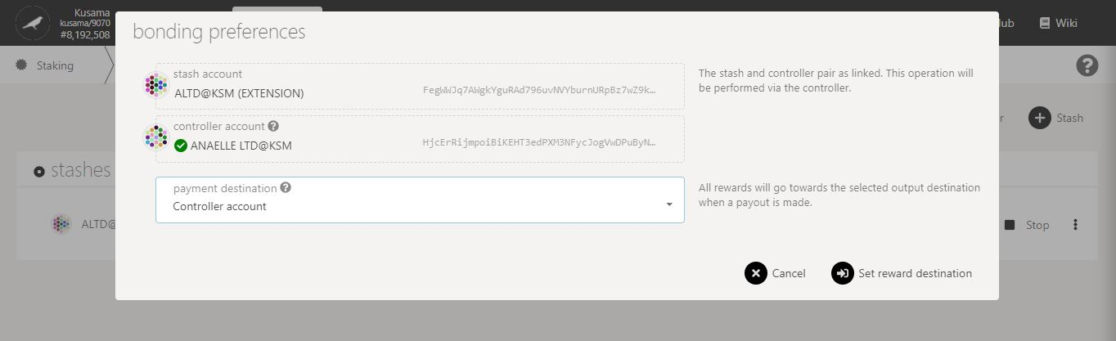

4. Click on **Set reward destination** to continue the procedure.

**Nature** of the transaction.

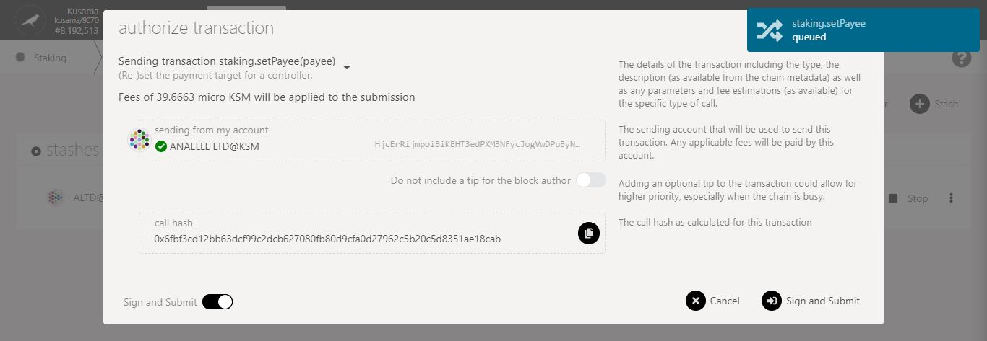

5. Check the **transaction fees**.

6. Click on **Sign & submit** to continue the procedure.

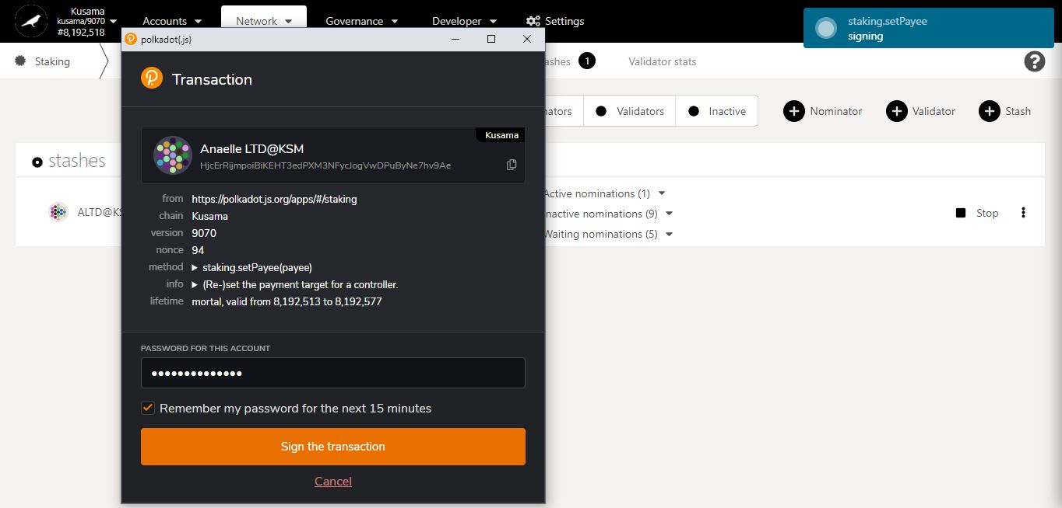

**Summary** of the transaction sent via the Polkadot-JS extension.

8. Click on **Sign the transaction** to complete the procedure.

**Progress** of the transaction.

7. Enter **your account’s password** and tick the box to **remember your password, if necessary**.

* **Set nominees.**



1. Click on the 3 vertical dots to view **Staking settings**.



2. Click on **Set nominees** to change your current selection of validators.

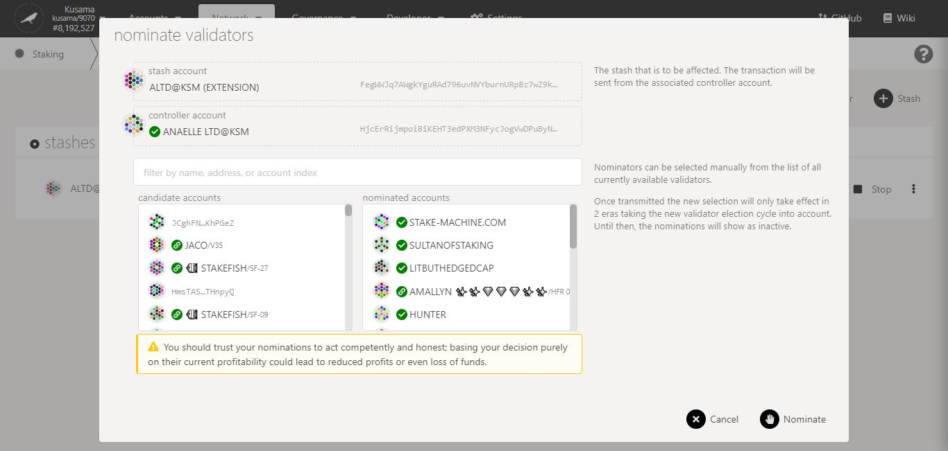

4. Click on **10-16** **validators’ names or addresses** to add them to **your selection**.

5. Double-check **warning messages.**

3. Follow the **new instructions** carefully.

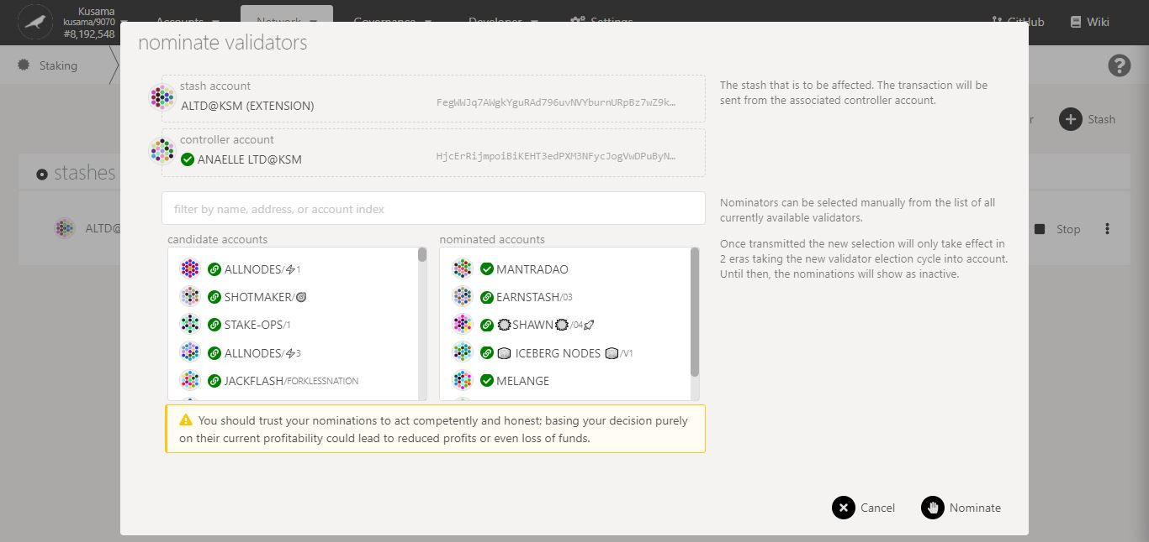

7. Click on **Nominate** to continue the procedure.

6. Double-check your **selection of validators.**

**Nature** of the transaction.

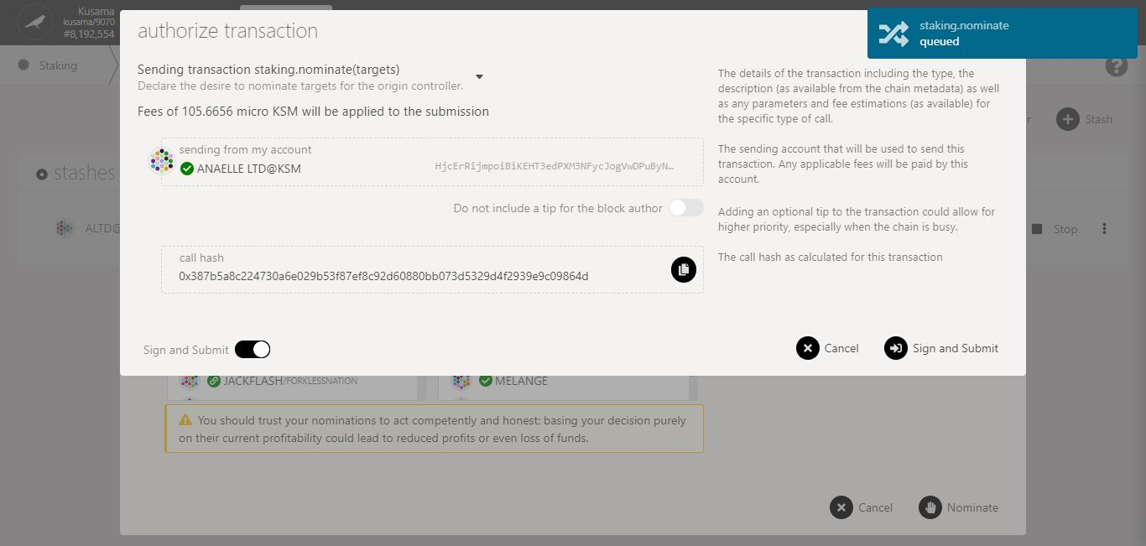

8. Check the **transaction fees**.

9. Click on **Sign & submit** to continue the procedure.

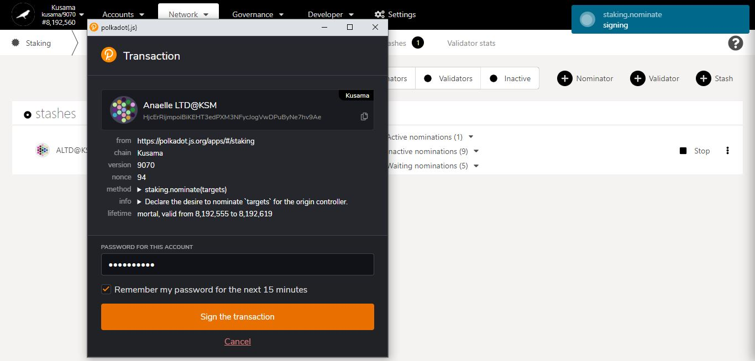

**Summary** of the transaction sent via the Polkadot-JS extension.

11. Click on **Sign the transaction** to complete the procedure.

10. Enter **your account’s password** and tick the box to **remember your password, if necessary**.

**Progress** of the transaction.

* 1. **Check payouts from recent eras.**

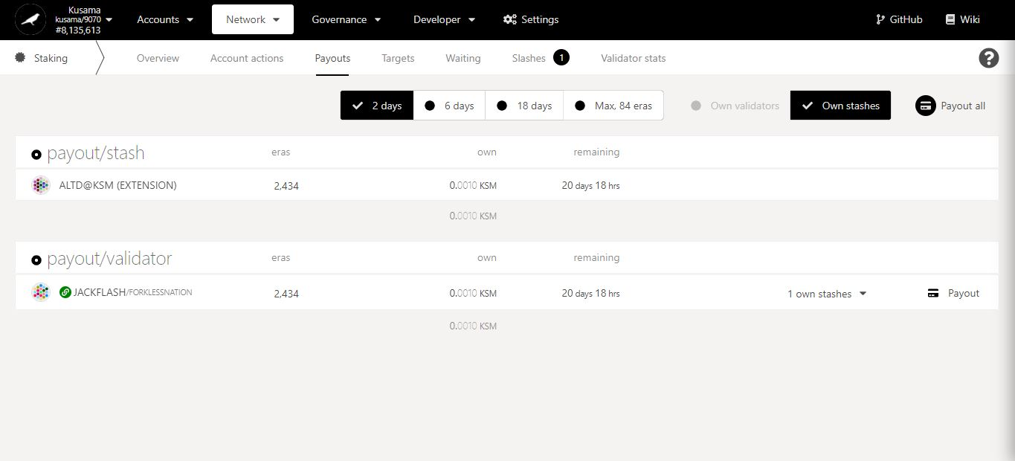

2. Click on **Payout (all)** to immediately receive rewards from your validator(s).

1. Click **Payouts**.

Time left for validators to **send the reward payouts**. Note: Most validators will send the reward payouts within a day.

Track all **rewards received and pending** for each individual era.

* 1. **Check nomination targets.**

1. Click **Targets**.

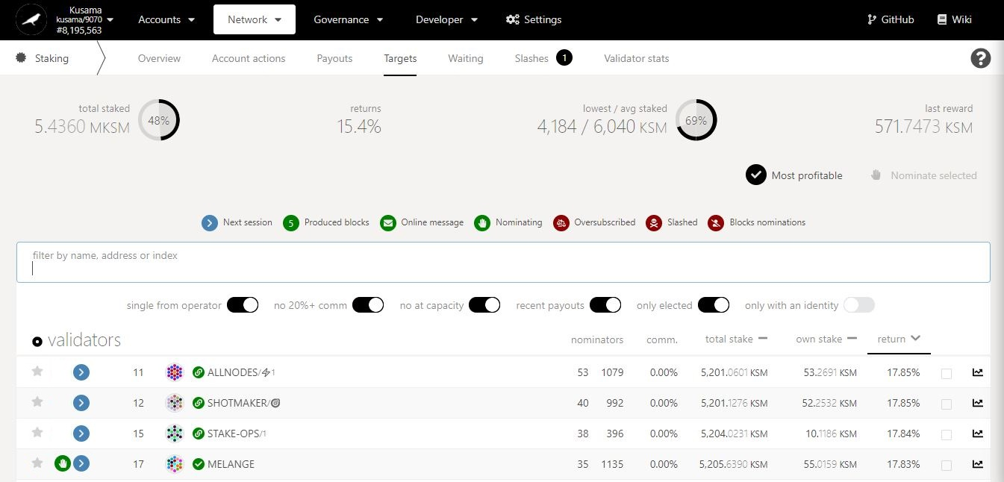

Key information on staking targets: **average returns, amount staked, and amounts rewarded.**

2. Switch the **filters ON** or **OFF** to display your **targeted data.** Ex: You can choose to view only validators who take <20% commission and are not full.

3. Scan through validators’ data and **compare it to your staking targets**.

This validator is in your **current selection of validators**.

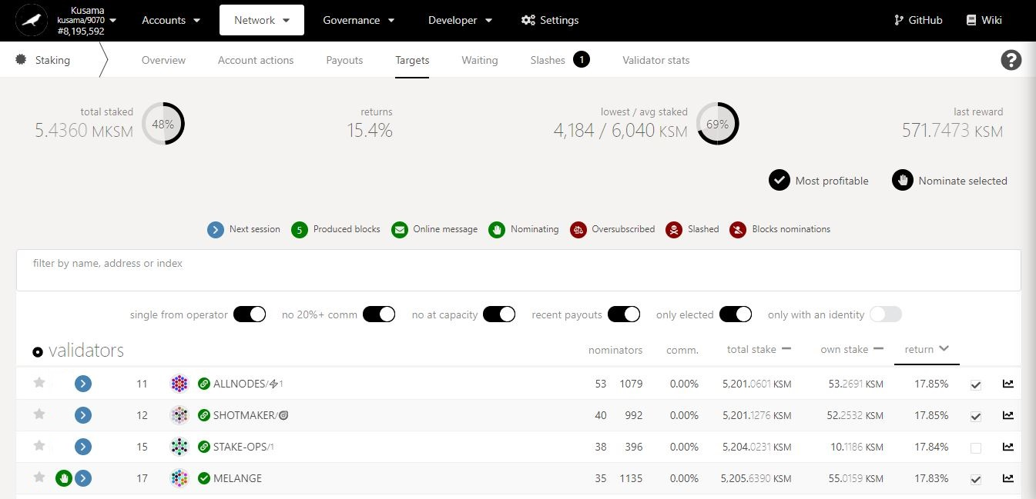

You can click **Most profitable** to **automatically select the top 16 rewarders**.

5. Click on **Nominate selected** to **replace your current list of validators** with a new selection. Note: If you do not select your current active validator, it will be removed!

4. Tick the box to select **10-16 validators that match** your staking targets.

* 1. **Check the list of waiting validators.**

1. Click **Waiting**.

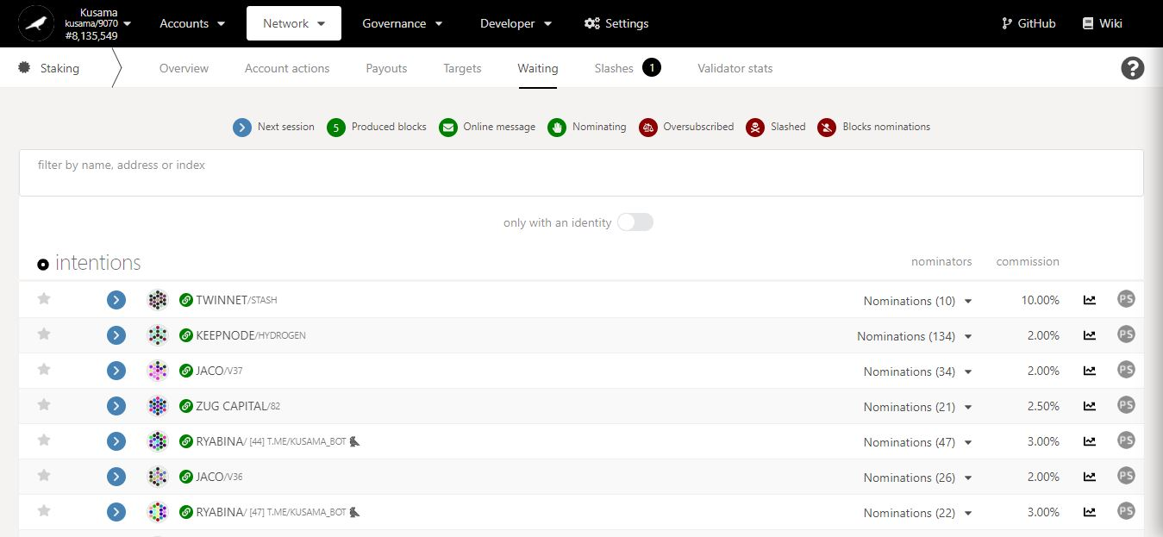

2. Click on **PS** to view a **validator’s statistics**.

Number of nominations **backing each unelected validator**.

* 1. **Check the list of slashed validators.**

1. Click **Slashes**.

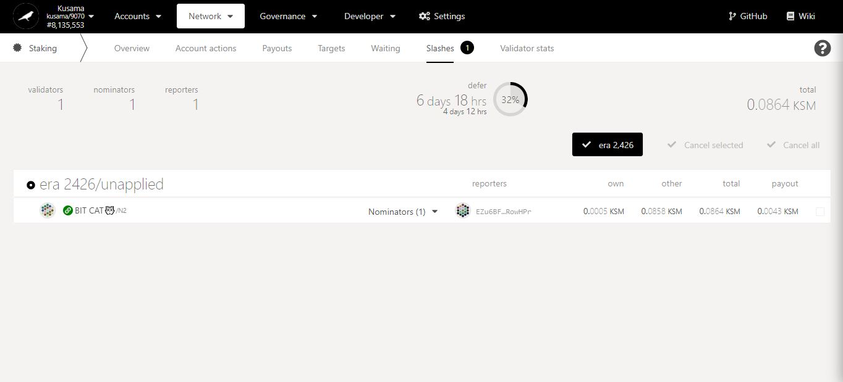

Key information on staking slashes: **validators & nominators concerned, time frames, amount.**

2. Click on the slashed validator’s name to view **a summary of its account.**

3. Click on the dropdown arrow to view **slashed nominators’ information.**

All amount slashed are used to **fund the Treasury**.

* 1. **Check the statistics of individual validators.**

1. Click **Validator stats**.

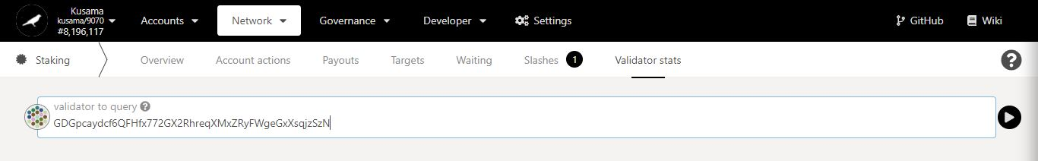

2. Enter/Paste the **address of a validator**, then click the **arrow** to view the validator’s information**.**

**Key validator history:**

- hourly points

- staking amounts

- election status

- rewards & slashes amounts

- commission %.

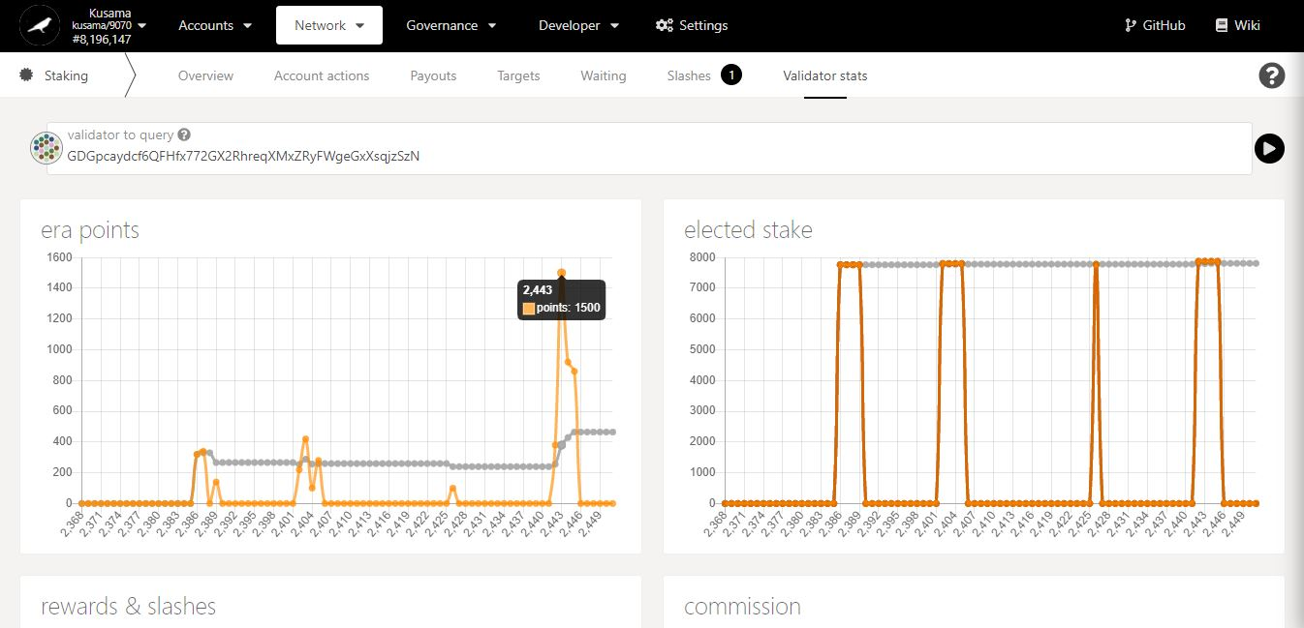

3. Move your mouse along the chart to get **detailed figures**.

1. **Parachains: Explore parachain-related activities.**



* 1. **View general parachain information.**

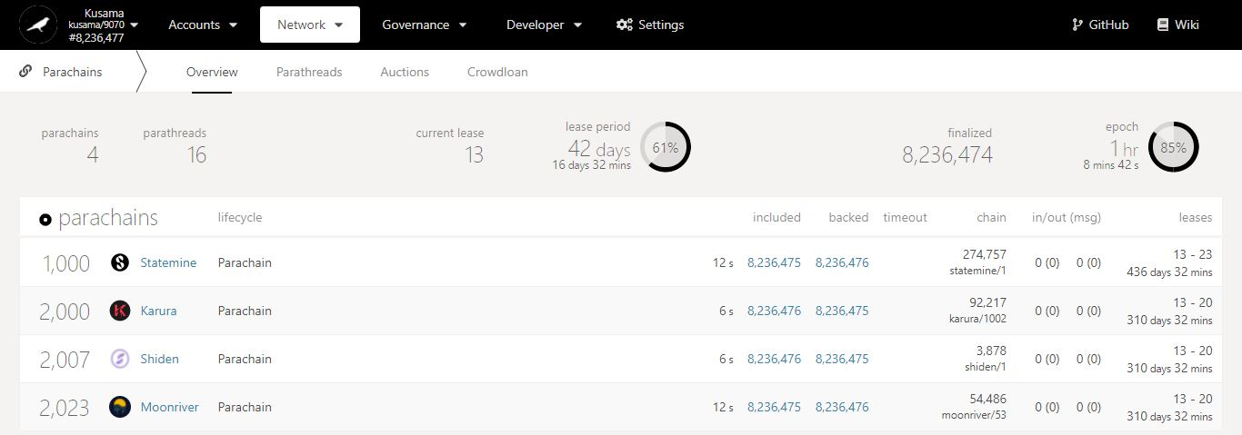

Key information on parachains: **waiting parathreads, current lease period’s ID, and lease period’s duration.**

Parachains summary:

- **Included:** Blocks produced by parachain collators.

- **Backed:** Blocks validated by relay chain (para)validators.

- **Chain:** Parachain runtime (chain spec) versions.

- **In/Out (msg):** Cross-chain messages sent/received by the parachain.

- **Leases:** Lease period IDs allocated to the parachain (when it obtained a slot) and their total duration (in days and minutes).

**Parachains** or **Parathreads**?

Registered **ParaIDs**.

Registered **names**.

* 1. **View onboarded parathreads.**

1. Click **Parathreads**.

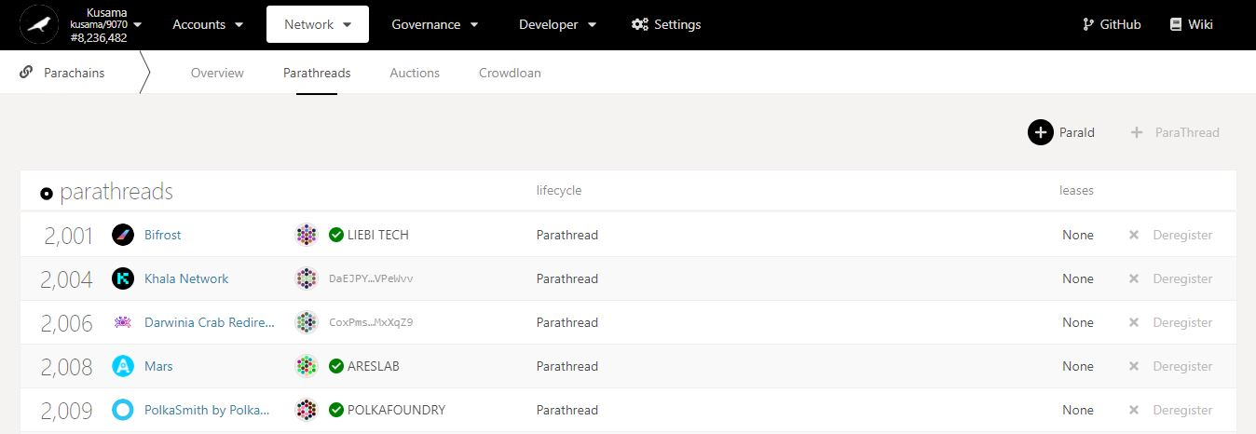

2. Click **ParaID** to register your network as a parathread.periods **obtained.**

Registered **names**.

**Parachains** or **Parathreads**?

Registered **ParaIDs**.

Leaseperiod IDs **obtained.**

Addresses of currently **registered parathreads**.

**NEVER SEND YOUR KSM TO A PARATHREAD’S ADDRESS!**

* 1. **View auctions’ progress.**

1. Click **Auctions**.

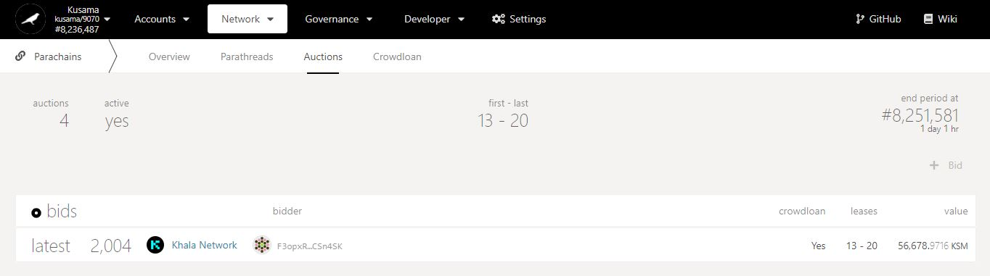

Countdown to auction’s end period (during which the winning bid will be determined).

Key information on auctions: **auction number, activity, lease period IDs, and timings.**

Is there a crowdloan campaign **associated to this bid**?

2. Check the latest bid(s) **included in recent blocks.**

**Targeted** leaseperiod IDs.

KSM amount **submitted for this bid.**

Addresse(s) of current **bidder(s)**.

**NEVER SEND YOUR KSM TO A BIDDER’S ADDRESS!**

* 1. **View and contribute to crowdloans.**

1. Click **Crowdloan**.

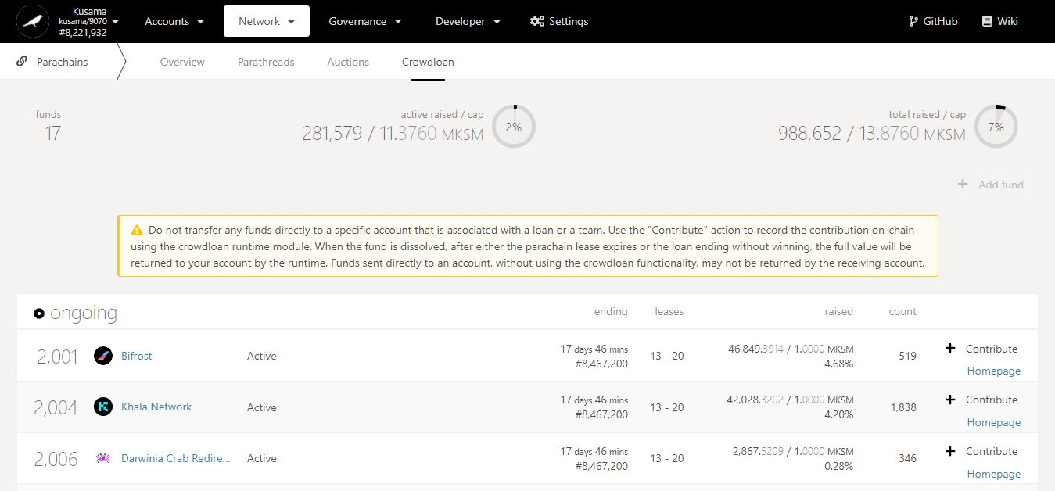

Time left **to fund a crowdloan** and **win an auction.**

2. Double-check **warning messages.**

Key information on crowdloans: **active funds, and KSM amount locked in funds.**

KSM amount raised by each fund **out of its total desired cap.**

3. Click **Contribute** to lend your KSM to a fund.

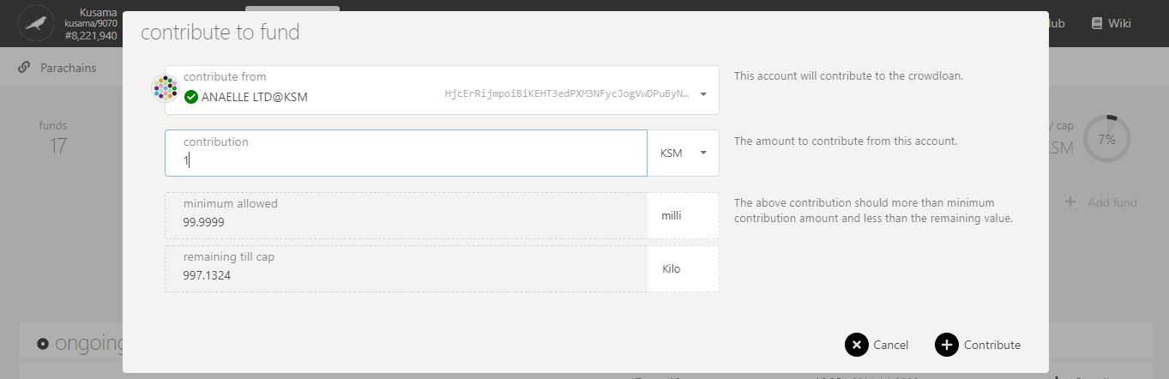

5. Click on **Contribute** to continue the procedure.

**Minimum** crowdloan contribution is **0.1 KSM**.

4. Follow **on-screen instructions** carefully.

**Nature** of the transaction.

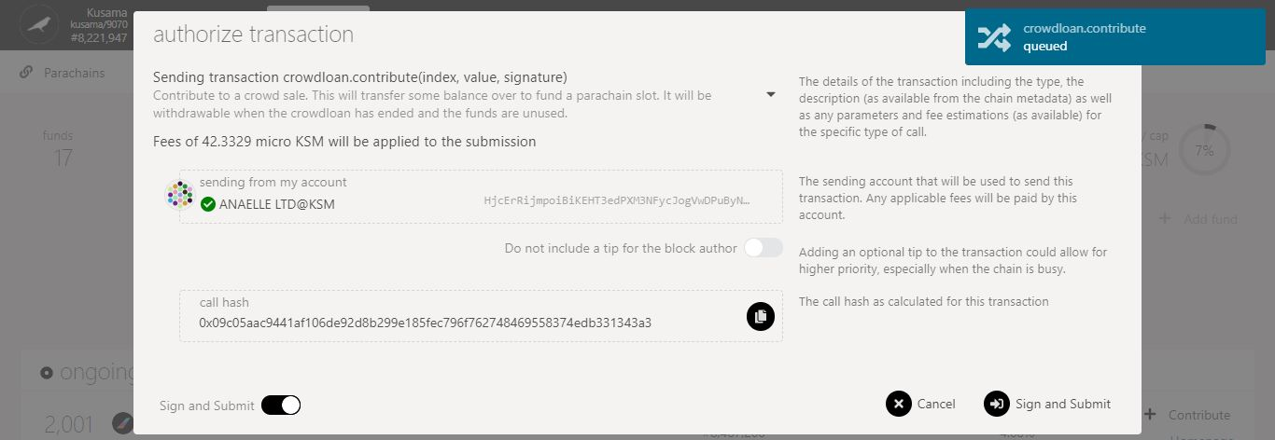

6. Check the **transaction fees**.

7. Click on **Sign & submit** to continue the procedure.

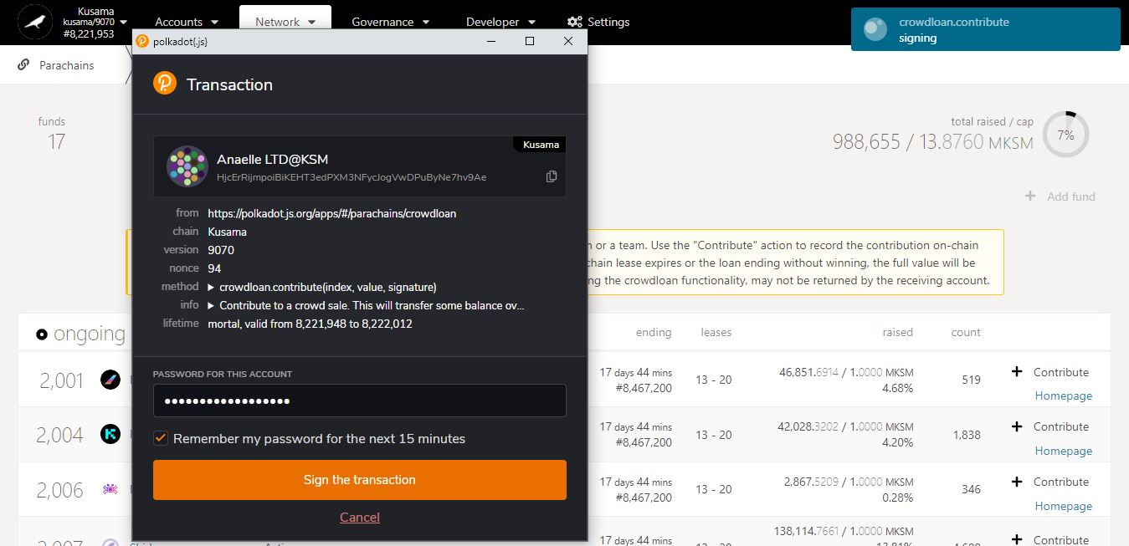

**Progress** of the transaction.

9. Click on **Sign the transaction** to complete the procedure.

**Summary** of the transaction sent via the Polkadot-JS extension.

8. Enter **your account’s password** and tick the box to **remember your password, if necessary**.

1. **Gilt: View and participate in auctions for inflation-protected KSM derivatives. [TBC]**



1. **Society: View and participate in *Kappa Sigma Mu* activities. [TBC]**



1. **Event calendar: Browse upcoming Relay chain events.**



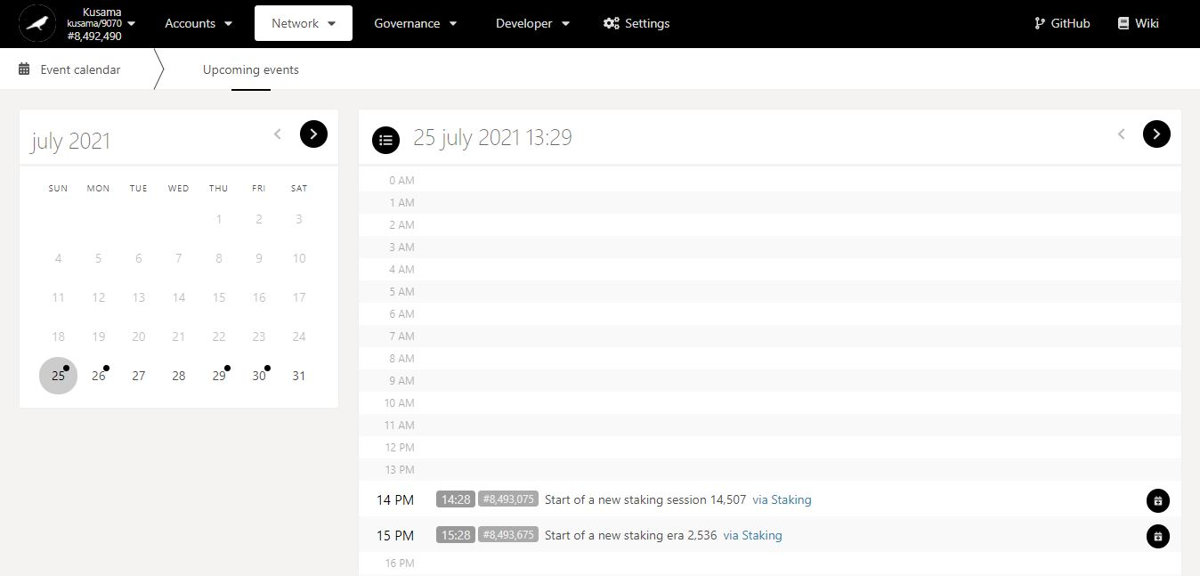

1. Click on a **day** to view its events.

Key information on upcoming events: **date, time, block number, description, and module.**

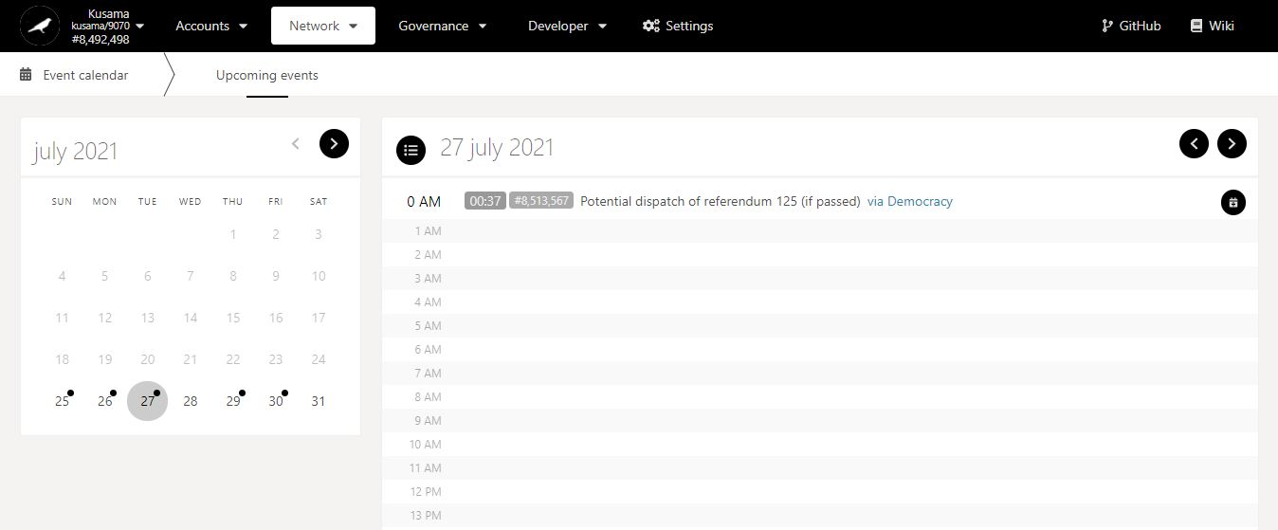

2. Click on the **module** to switch view on *Polkadot-JS Apps*.